


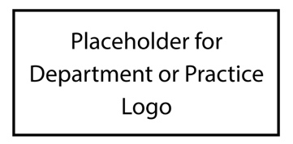


Patient Experience Week!

- Insert highlights here.
- Insert highlights here
- Insert highlights here
- Insert highlights here
- Insert highlights here
- Insert highlights here
- Insert highlights here

To re-energize and enhance human connections between colleagues and healthcare teams with the common goal of improving the patient experience;

To provide opportunities for team members to maintain and/or improve their health and well-being;

To honor those that impact patient experience every day.

Goals:
What you can look forward to:
April 27 – May 1, 2020
“The Patient Experience is the sum of all interactions, shaped by an organization’s culture that influence patient perceptions across the continuum of care.”
– The Beryl Institute

