
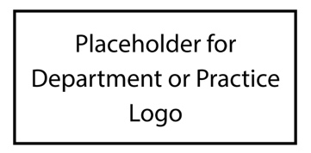

“The Patient Experience is the sum of all interactions, shaped by an organization’s culture that influence patient perceptions across the continuum of care.”
– The Beryl Institute

Insert Dates Here
Patient Experience and Self-Care Challenge
Day 5 challenge goes here.
FRIDAY
TUESDAY
Day 2 challenge goes here.
Day 3 challenge goes here.
WEDNESDAY
THURSDAY
Day 4 challenge goes here.
Day 1 challenge goes here.
MONDAY
We are ALL the Patient Experience!

