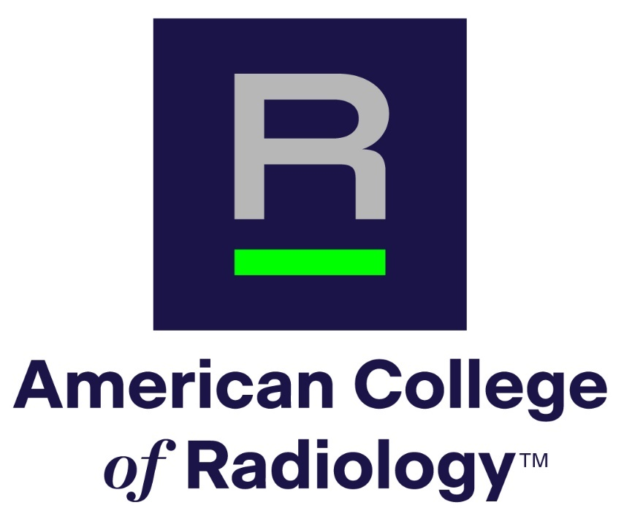
APPLICATION FORM
AMERICAN COLLEGE OF RADIOLOGY
Richard L. Morin, PhD Fellowship in
Medical Physics

- General Information
- Name:
- Institution and/or residency program:
- E-mail:
- City & state:
- Phone:
- Subspecialty (if applicable):
- Name of Program Director:
- Department Chair (if applicable):
- Current year in residency:
- Expected year of residency completion:
- Please identify two current top areas of interest
- Area 1:
- Area 2:
- Please choose at least one accreditation modality or program of interest:
- Program 1:
- Program 2 if applicable:

- Personal statement describing how this fellowship relates to your career goals. Please do not exceed 500 words.

- What prior experiences (activities, courses, and jobs) have best prepared you for this fellowship? Please do not exceed 300 words.

- Why are you applying for this fellowship and what do you hope to gain from it? Please do not exceed 300 words.

- Please save and submit this application as a pdf through the submission page
- Please include a copy of your CV, as indicated on the submission page
- Please have a professional portrait available in case of selection for the award
- Please have your 2 Reference Letters submitted through the upload portal linked on the Morin Fellowship landing page

Questions? Please email Dustin Gress, ACR Senior Advisor for Medical Physics:
dgress@acr.org

